**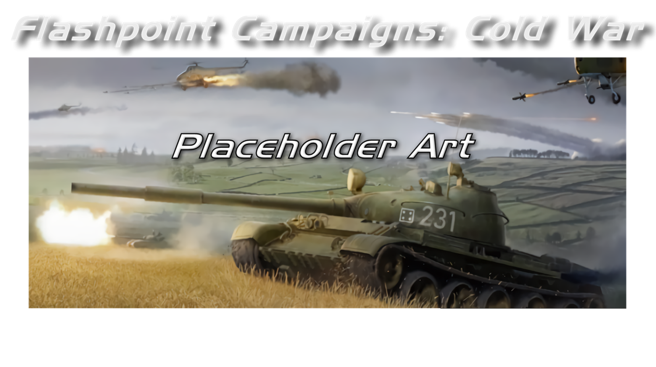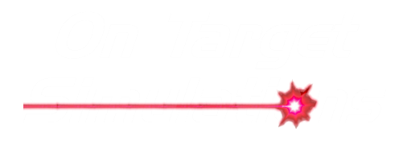

Battle Planning

Field Manual FCCW-05/R0

**© 2025 On Target Simulations, LTD. All Rights Reserved. The images used and OTS Logo are property of On Target Simulations, LTD. All other marks and trademarks are the property of their respective owners.**

Table of Contents

1 Introduction 4

1.1 What's in This Document 4

1.2 What's Not... 4

1.3 Game Manuals 4

1.3.1 The Field Manuals (FM) 4

1.3.2 The Operational Area Guides (OAG) 4

1.3.3 What's New 5

1.3.4 FPC Hotkeys 5

1.3.5 FCCW Southern Storm Game FAQ 5

1.4 Gender Pronouns and Inclusion 5

2 Getting Started 5

3 Creating Battle Plans 6

3.1 Movement 9

3.2 Artillery 16

3.3 Engineering 22

3.4 Helicopters 28

4 Battle Plans SOPs 28

4.1 SOP Manager 28

4.2 Set SOPs 29

4.3 Adjust SOPs 30

5 Battle Plans for Off-map Artillery and Air Force 32

5.1 Off-map Artillery 32

5.1.1 Impacts of Artillery Barrage 34

5.2 Off-map Air Force 34

5.2.1 Impact of Air Strike Waypoints 36

5.2.2 Execution of Battle Plan Air Strikes 36

5.2.3 Execution of Non-Battle Plan with Off-map Air Strikes 37

6 Battle Planning Dos and Don’t 37

7 Flashpoint Campaigns Credits 39

7.1 On Target Simulations Team 39

7.2 Cold War Contributors/Testers 39

7.3 Cold War Beta Testers 39

7.4 Matrix Production Manager 39

OTS on the Web 40

# Introduction

Welcome to "***Flashpoint Campaigns – Cold War: Battle Planning!"*** This is the first of three documents explaining Content Creation for the game system. This manual will explain the basics of how you make scenarios for the game.

## What's in This Document

This document describes how to add Battle Plans for the AI to choose during a scenario and provides a means of replayability to any scenario for both sides in the fight. The more plans you add the more options the player has to replay with a different enemy plan.

We provide some of the basic "dos and don'ts" of modern tactical warfare, but not an army training manual deep. We try to impart lessons learned from the game and those elements of real-world tactics that apply and can save your backside in this game.

## What's Not...

*How to operate the game.* That information can be found in FM01: Game Operations.

*How to fight in modern warfare*. That information can be found in FM02: Battlefield Primer.

*How to modify the game engine*. That information can be found in FM07 through FM10.

*Detailed information for each unit, weapon, and sensor of each country*. You can get many of those particulars from the in-game Sub-Unit Inspector (SUI) or by searching the web.

## Game Manuals

We have chosen to go with many living manuals to cover game interface/play, learning the game, basic tactics, Content Creation, and Game Modding for the Cold War game engine. We also have guides that cover that area of operations.

The affected manuals and guides will be updated as the game is updated, and PDFs of these changes will be included with the new patches.

### The Field Manuals (FM)

These are the core manuals on how to play, create content for, and modify data for the Cold War game engine. Before jumping into Content Creation, we strongly recommend you review the first three manuals, **Game Operations**, **Battlefield Primer**, and **Tutorial Operations** if you are new to this type of game and warfare. Returning Red Storm players should review **Game Operations** to get details on new features, as there are many.

These documents are found in the Documents\FMs folder.

* FM01: Game Operations – Detailed information on the game, its interface, and how to use it
* FM02: Battlefield Primer – Fighting in the Cold War
* FM03: Tutorial Operations – How to learn and play the game
* FM04: Scenario Design – How to make or edit scenarios
* FM05: Battle Planning – ***This Manual*** -How to create or edit battle plans. Battle Planning is a unique topic of Scenario Design.
* FM06: Campaign Design – How to make or edit campaigns
* FM07: Map Construction – How to make simple maps for the game
* FM08: Game Modifications – How to revise elements of the game
* FM09: Data Structures and Editing – How to edit or build data sets
* FM10: Weather Setup – How to add in weather from other locales

### The Operational Area Guides (OAG)

The Area Guides cover each Cold War game module (Southern Storm being the first) and provide more in-depth information about the scenarios, campaigns, maps, and forces. New DLCs (Downloadable Content) will have additional OAGs to cover their content.

These are found in the Modules\FCSS\Documents folder.

* OAG01: SitRep: Southern Storm - Overview of campaigns and scenarios
* OAG02: Forces Review – Country summaries and primary equipment
* OAG03: Battlefield Survey – Maps of the area and information

### What's New

The What's New PDFs summarize any changes and fixes when updates are done.

These can be found in the Documents\WhatsNew folder.

### FPC Hotkeys

This PDF document lists all the game presses for Function keys and all hotkey definitions. Rebinding keys isn't possible due to the extensive array of functions present in the game.

This document is in the \Documents folder.

### FCCW Southern Storm Game FAQ

To stave off forum-clogging threads on topics we either don't control or can't support, we created this FAQ document with the answers to those topics.

Please review the FAQ for answers to several game topics related to the game but not on how to play the game.

This document is in the \Documents folder.

## Gender Pronouns and Inclusion

We are happy that our game has fans and players of all genders. We try to keep language in the game and manual gender neutral, when possible, but sometimes use the pronoun “he” to refer to the player. This is merely to streamline the writing, not to exclude anyone or note a specific gender. The On Target Simulations team supports the inclusion of all people in the field of wargaming.

# Getting Started

“The process of battle planning involves utilizing a straightforward visual scripting system to enhance the existing artificial intelligence of computer players. This system incorporates user-generated battle plans into the ongoing analysis engine, aligning with the 'Commander's Intent' at the appropriate juncture. While specific missions are not obligatory, they are typically adhered to in 99% of cases.”

Videos made by On Target Simulations LTD on making Scenarios and Battle Plans are posted at this link: [How to Create a Scenarios](https://www.youtube.com/watch?v=iULAXVVscbY)

Once you have created your forces as outlined from **FM FCCW-04/R1** **Scenario Design**. And you have placed them on the map. Let’s get started on Creating a Battle Plan. But first, let's look at a Battle Plan that has been created and see how it looks.

Fig 1 shows an example of how a Battle Plan would look when the information is displayed in the Players Order of Battle, in the Battle Plan tab.

Fig 2 shows the Battle plan displayed on a map showing the routes and the type of missions.

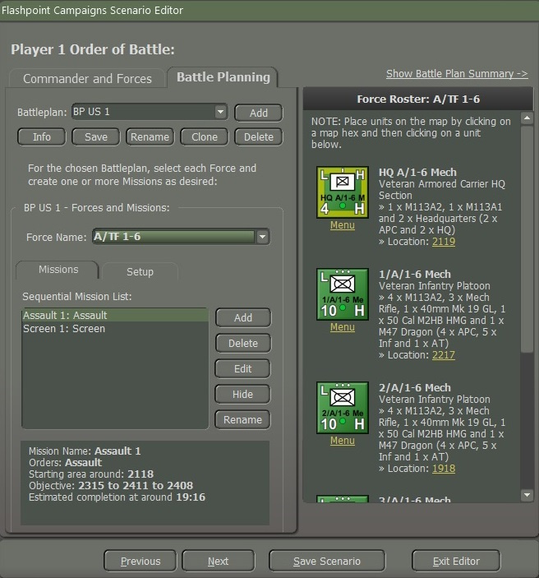

Fig.

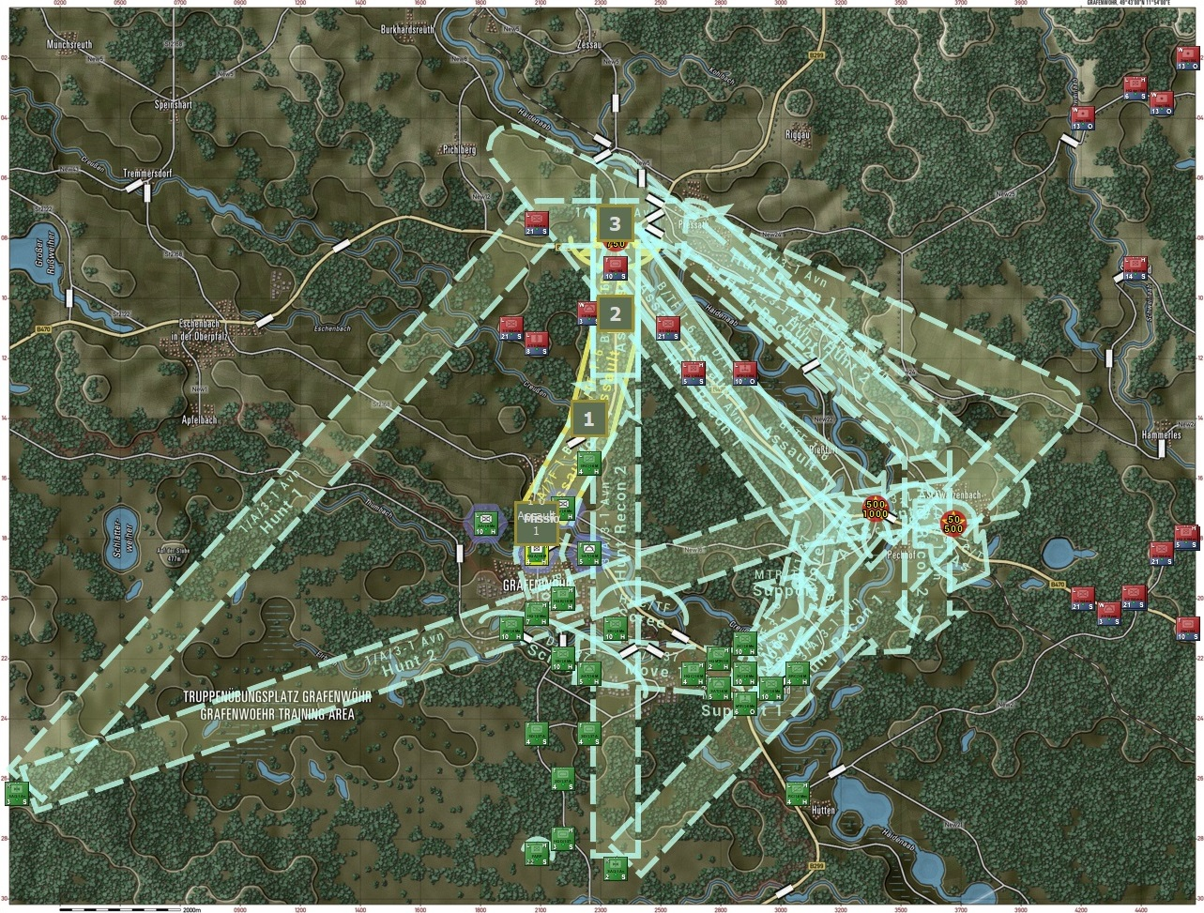

Fig.

# Creating Battle Plans

A couple of things to remember, BPs are not required. Forces do not have to have Battle Plan Missions. If the unit does not have a mission, the AI will move the units as it sees fit. A single Battle Plan can be units or forces moving to different locations with no assigned mission. A Battle plan can contain some units/forces with missions and some without. You can use them to set up the units on the map or add BP missions to move units into a particular location and then let the AI take over or have detailed missions.

Also, each mission has a time limit (set by the program – the human designer has no control). Once the time limit is reached, the mission is canceled, and it advances to the next mission, or the AI takes over.

If the mission is too long and involved, it may not be completed before the time limit is reached. It is better to set smaller missions chained together. There is no limit to how many missions there can be.

So, after creating your forces and you place them on the map. Select the Battle Planning tab as shown in Fig. 3.

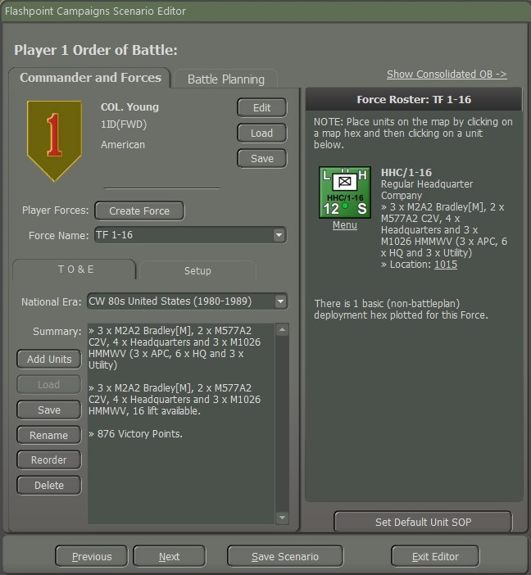

Fig. 3

A screen will show the Battle Planning highlighted as shown in Fig. 4.

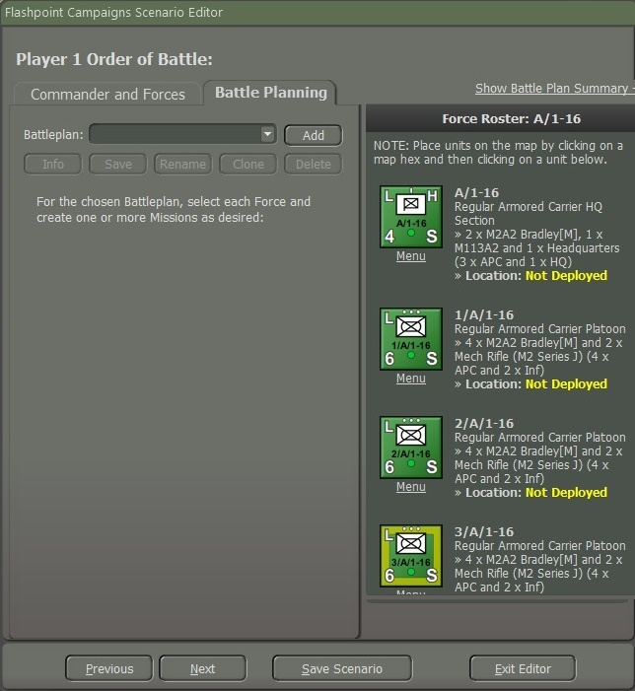

Fig. 4

You noticed that even though you placed the forces on the map during the “Creating Forces” it shows that the unit is not deployed as shown in Fig. 4. To add a mission, select the “**Add**” button as shown in Fig. 4.

As shown in Fig. 5, You need to enter a name for the Battle Plan. You should name it “BP US 1”, “BP1 US”, or “US BP1”.

You want to give a number to the BP and the Nationality indicator for which we will use “US” for the United States as shown in Fig. 5.

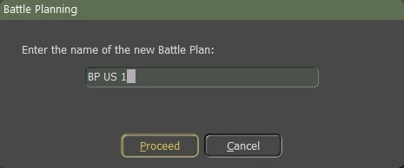

Fig. 5

This part is crucial if you do this wrong. If you select the “**Yes**” button, the units that you deployed on the map will be placed back as “Not Deployed”, and you will have to redo deploying the forces back onto the map. If you select the “**No**” button, the units you have placed on the map will remain where you deployed them.

We will select the “**No**” button as shown in Fig. 6.

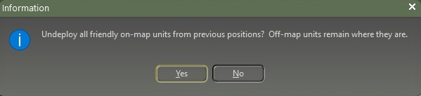

Fig. 6

Before we begin to build a Battle plan for the first Task Force let's look at Fig. 7, there are five (5) buttons,

1. **Info:** This shows the Info screen.
2. **Save:** Fig. 8 shows the location of the save file for BP US 1 which will be in the folder of the scenario. Each save BP will be added to the folder of the scenario. It is best that anytime you add/make changes to the BP save as often as possible.
3. **Rename:** To rename the new Battle Plan.
4. **Clone:** When selected, a popup screen to enter a new name to the new plan duplicates a current battle plan to a new one.
5. **Delete:** Selecting this button will delete the current Battle Plan.

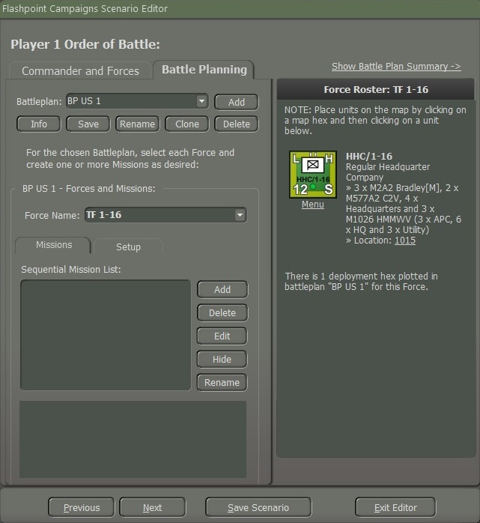

Fig. 7

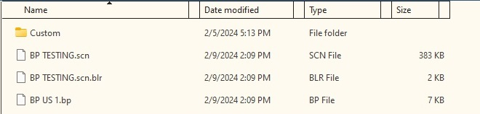

Fig. 8

Battle plans are created in the Scenario Editor. Multiple alternative battle plans may be created per side per scenario, but only one will be in effect for the game. The player will be allowed to choose which one is in effect for the computer player, and if desired, may use a randomly selected one to vary play.

## Movement

We open the “Battle Planning” tab to select a task force and set up missions. We will select A/1-16 and by using the “**Ctrl**” key and right-click on it, it will select all the subordinates in the company. Select the “**Add**” button as shown in Fig. 9. When you select the “**Add**” button a popup screen as shown in Fig. 9 will appear. We will type in the name box “Mission 01” and then select the “**Proceed**” button.

**NOTE:** Each “Mission Name” for a force must be unique.

**NOTE:** When you create one or more Missions for each task force. You must create them in chronological order, as the ending point of one will become the starting point of another.

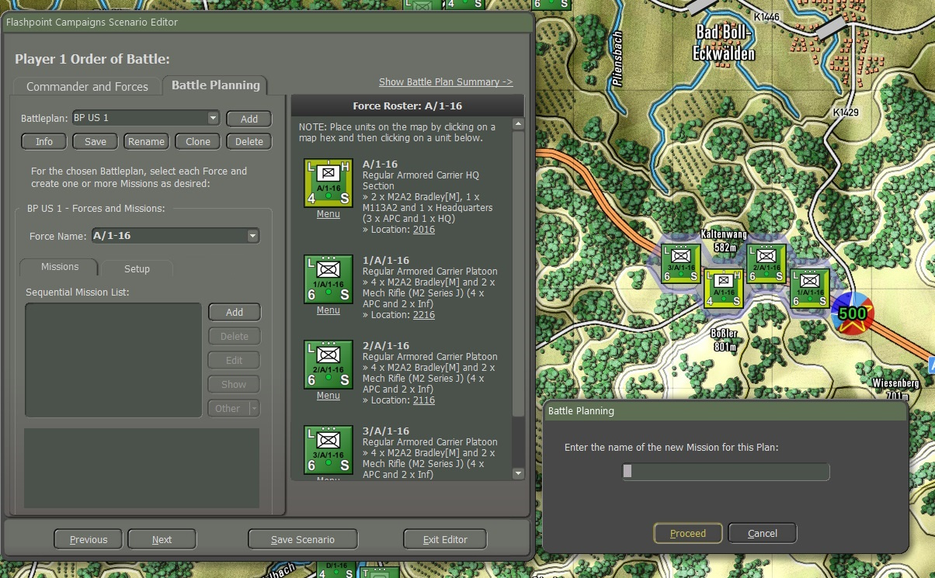

Fig. 9

Once you select the “**Proceed**” button a mission icon will appear on the A/1-16 unit as shown in Fig. 10.

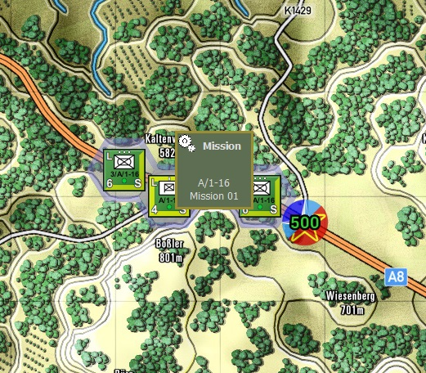

Fig. 10

When the Mission icon appears on the unit, simply right-click it to reveal a menu of permissible mission directives. These directives closely resemble the unit orders with identical objectives that can be assigned to them as shown in Fig. 11.

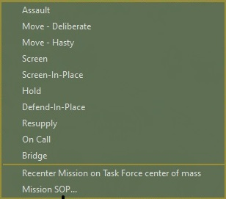

Fig. 11

We’re going to give it the mission “Move-Deliberate” on, and off the road but defensively as shown in Fig. 12.

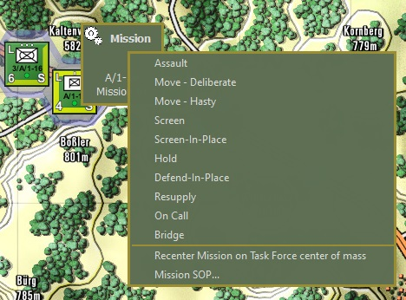

Fig. 12

When you select “Move-Deliberate” a screen will pop up as shown in Fig. 13. You can use just one waypoint or up to three waypoints. Because it is an IFV company we will use all three of them and select the “**Commit**” button as shown in Fig. 13 after placing the waypoints.

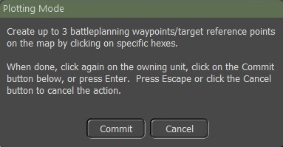

Fig. 13

As shown in Fig. 14 we placed three waypoints. You can also move a waypoint to a different location on the map, to move the route as shown in Fig. 15.

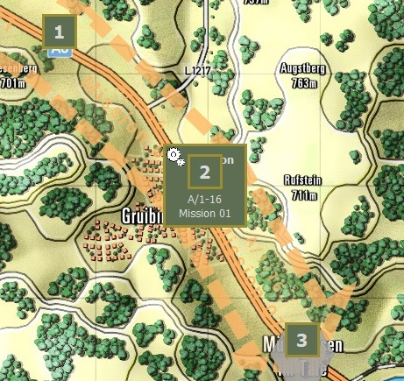

Fig. 4

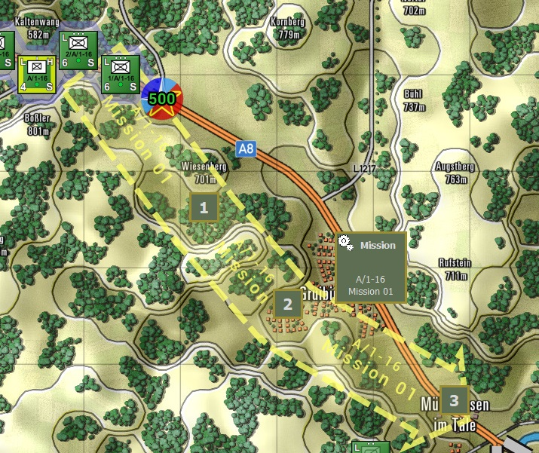

Fig. 15

For the next mission, select the “**Add**” button we’re going to label this mission as “Screen 01” then select the “**Proceed**” button. A new mission icon will pop up over the end part of the first mission as shown in Fig. 16. We’re going to select the “Screen-in Place”. Select the “**Edit**” button and a screen will pop up as shown in Fig. 17.

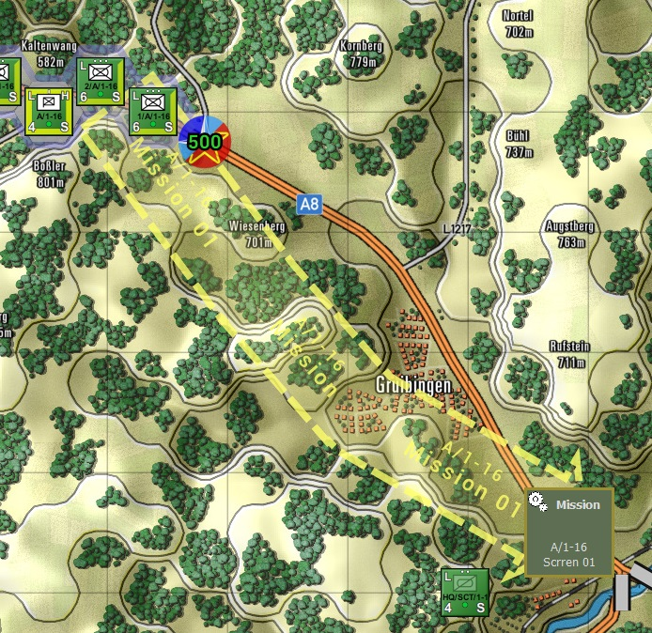

Fig. 16

As illustrated in Fig. 17, “A/1-16 Mission Parameters”. Screen-in-Place Orders Staff estimate the time from 07:00 to 15:00 approximately.

**NOTE:** Make the changes to the Mission SOP, Duration, and Frontage first before selecting the “**Proceed**” button.

1. Mission SOP, as shown in Fig. 17
2. Duration, how long is the time for Screening in Place? For this mission, it will be 60 minutes as shown in Fig. 18
3. Frontage, the default frontage (m) is 500m. You can set it to whatever you want it to be as shown in Fig. 19, you can adjust the size of the frontage, and the symbol for the screen will get large or small.

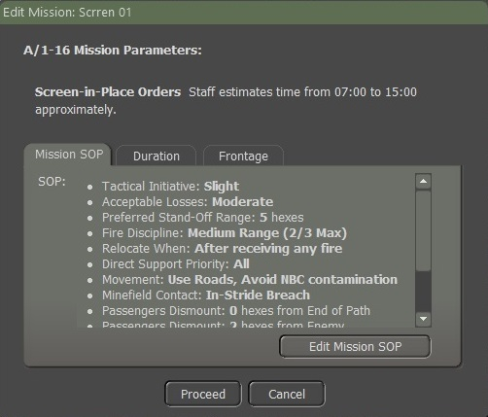

Fig. 17

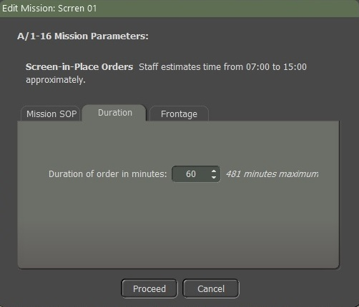

Fig. 18

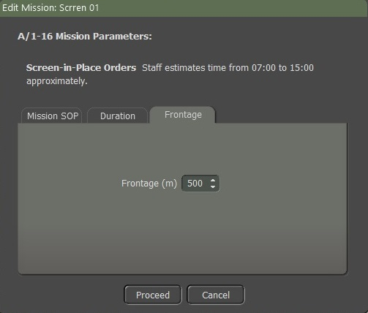

Fig. 19

The last mission to add is “Resupply” as shown in Fig. 20.

To edit and/or look for it on the map for the mission that is listed in the “Sequential Mission List”. Just highlight it and it will show on the map.

To delete a mission just highlight it and select the “**Delete**” button as shown in Fig. 20. But you can only delete the last mission. This example is “Resupply 01” and the “**Delete**” button will be active and not grayed out. You cannot delete the mission before it. You must delete sequential from the last to the next to last and so on.

To hide a mission on the map, just select the “**Hide**” button and all the routes and missions will be removed from the map.

When you want them back on the map, just select the “Show” button that has replaced the “**Hide**” button.

Select the “**Rename**” button if you need to change the name of the mission to a popup screen as shown in Fig. 21 to rename the mission.

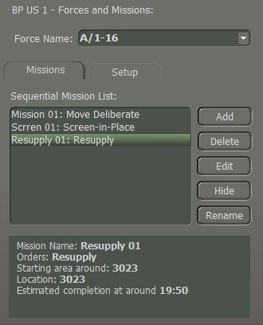

Fig. 20

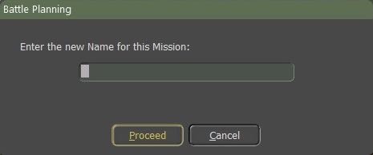

Fig. 21

## Artillery

After finishing the Mission for A/1-16 we will select another task force and set up missions for it. We will select 2-5 FA and by using the “**Ctrl**” key and right-click on it, it will select all the subordinates in the Artillery battalion. Select the “**Add**” button as shown in Fig. 9. When you select the “**Add**” button a popup screen as shown in Fig. 9 will appear. We will type in the name box “Mission 01” and then select the “**Proceed**” button.

**NOTE:** Each “Mission Name” for a force must be unique.

**NOTE:** When you create one or more missions for each task force. You must create them in chronological order, as the ending point of one will become the starting point of another.

**NOTE:** Order/Delay between artillery missions. For the US, it's 5 minutes. Add another minute for issuing the order and it’s 6 minutes between rounds landing from hex to hex for a firing unit.

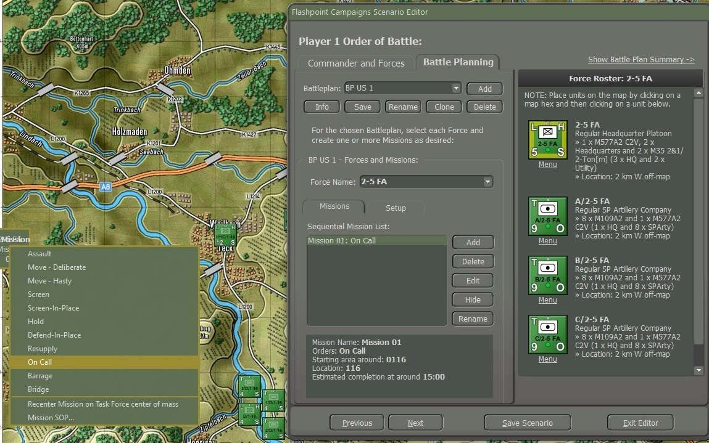

Fig. 22

Right-click on the mission icon and then select “On Call” as the first mission.

Select the “**Edit**” button as shown in Fig. 22, to make changes to the “Mission SOP” and to adjust the “Duration” of this mission “On Call”.

Because it is an “On Call” mission we are going to use “Shoot and Scoot” Go to the “SOP” tab and select “Artillery/Scoot and Shoot”. Another screen will be displayed as shown in Fig. 23.

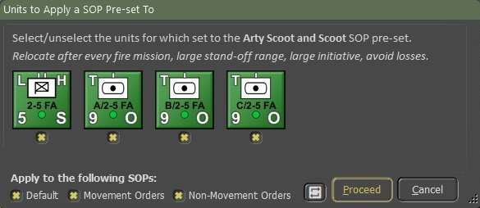

Fig. 23

Fig. 23, shows that all the units in 2-5 FA will all get the same SOP for Scoot and Shoot” for an “On Call” mission. If I don’t want B/2-5 FA to have the same “SOP”, I need to uncheck the “**x**” under the unit icon first before selecting the “**Proceed**” button as shown in Fig. 23.

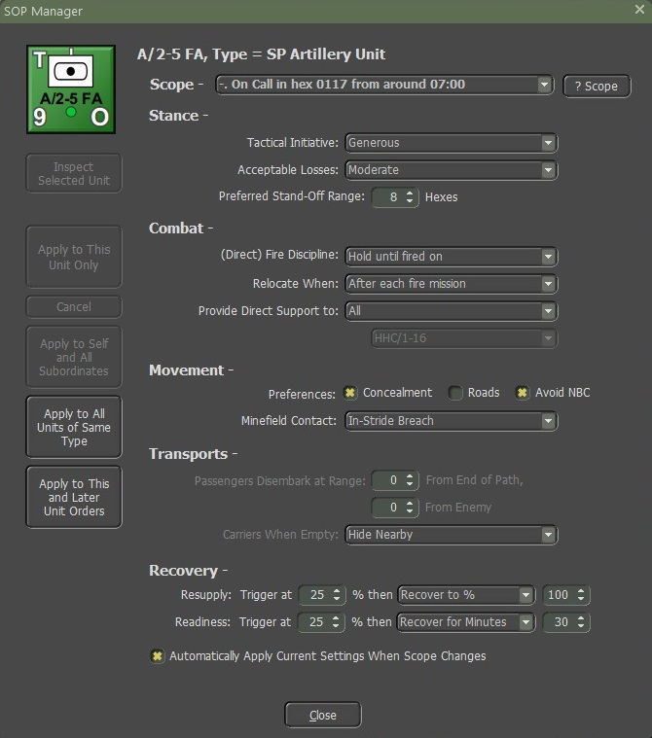

Fig. 24

The Presets for the Scoot and Shoot shown in Fig. 23, will update the SOP Manager as illustrated in Fig. 24. You can also make changes by using the Adjust SOP.

We’re going to create another mission; this one will be a “March” mission.

Let’s select the “**Add**” button and then select “Move-Deliberate” as shown in Fig. 25.

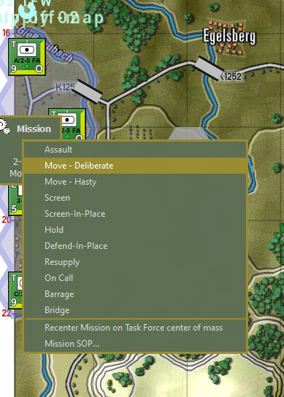

Fig. 25

You will then get a screen as shown in Fig. 26. As shown in Fig. 27 we placed three waypoints. You can also move a waypoint, to move the route and then select the “**Commit**” button.

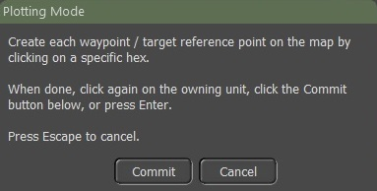

Fig. 26

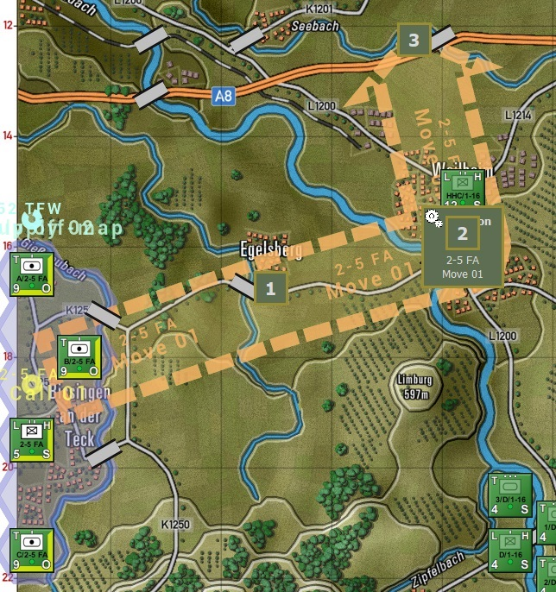

Fig. 27

Inside the graphics are the unit's name and the mission label as you can see in Fig. 27.

The third mission will be a “Barrage” Select the “**Add**” button and then select “Barrage” as shown in Fig. 28.

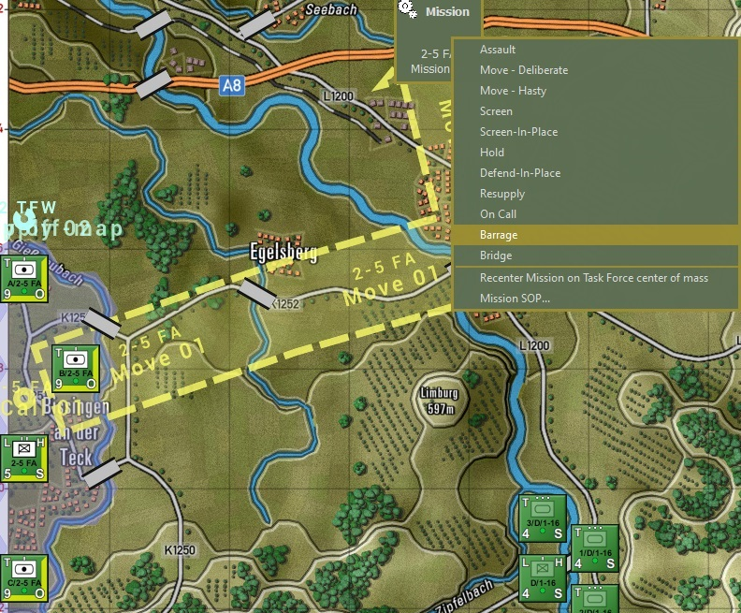

Fig. 28

When you select “Barrage” a screen will pop up as shown in Fig. 29. You can use just one waypoint or up to three waypoints. Because it is an Artillery Battalion with three batteries, we will use all three and select the “**Commit**” button as shown in Fig. 29 after you mark the waypoints for the barrage.

When assigning barrages to a BP, you are allowed to set 3 waypoints. Each waypoint is assigned to a battery in the force. So, you can only assign a WP to each of the 3 batteries in a barrage mission. If you have 4 batteries in a force, the 4th one will not be assigned a WP. The WPs are assigned based on their position in the formation.

The first battery will fire at the 1st WP and so on. When you set a Barrage Mission, all three batteries (if there are 3 batteries) will fire if they have the ammo for that Barrage Mission.

To fire different types of ammo, you must have a barrage mission for each type of ammo. For example, one battery has HE and smoke, another has HE and non-persistent chem, and the third has HE and persistent chem rounds (in reality, they all three had smoke rounds, but for this example, I'm pretending that only one had it).

I fired first a smoke mission and set the three WP. I placed the WP for the battery with the smoke where I wanted the smoke to go. The other two did not fire so it did not matter where their WPs were. The second barrage was for non-persistent chem. I again placed my three waypoints with the one for the battery with non-persistent chem where I wanted the NP chem to land. I did the same for the third barrage for persistent chem.

**NOTE:** As for Nukes, during the time of writing this FM Battle Planner, Nukes is a problem for the Developers. Hopefully, soon it will be working as planned.

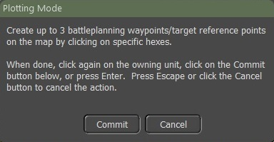

Fig. 29

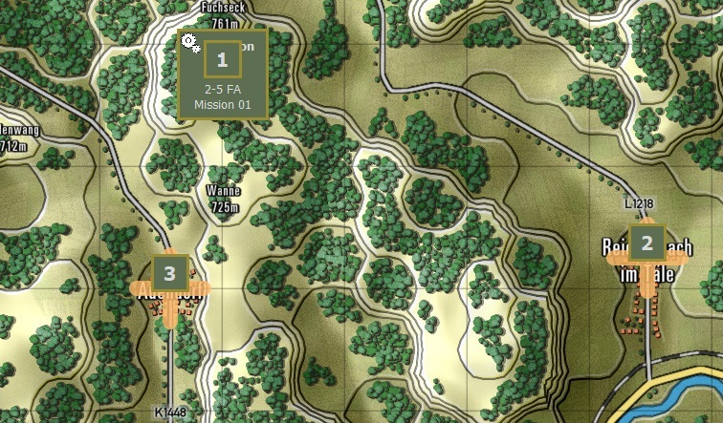

Fig. 30

Fig. 30 shows all three barrage waypoint markers on the map.

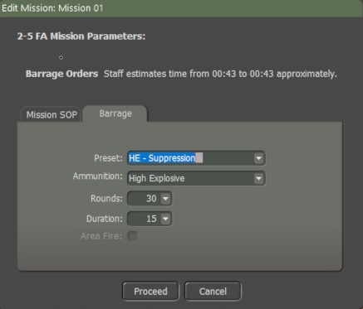

Fig. 31

Once you place the three waypoint Barrages on the map select the “**Edit**” button. A screen will pop up as shown in Fig. 31. Mission SOP should have been checked to make sure that is the SOP that you want for this mission.

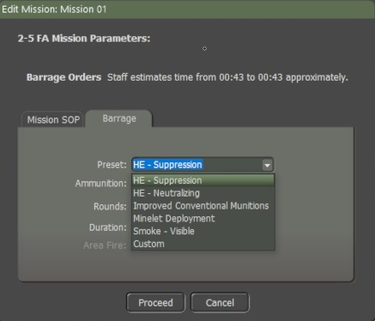

Fig. 32

Select the “Barrage” tab as shown in Fig. 31. Fig. 32 shows all the types of a Pre-set fire mission.

* HE-Suppression
* HE-Neutralizing
* Improved Conventional Munitions
* Minelet Deployment
* Smoke-Visible
* Custom

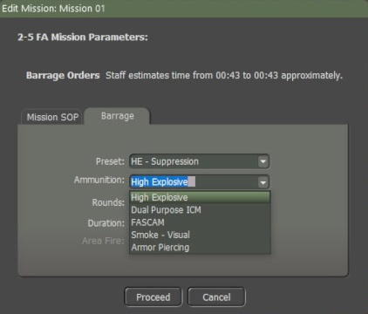

Fig. 33

Use the drop-down for all the ammunition types as shown in Fig. 33.

Fig. 31 shows “Rounds” and Duration”. The default for Rounds and Duration are 30 for rounds and 15 for the duration. When you make changes to either rounds and/or duration the preset switches to “Custom” when you select the “**Proceed”** button.

**NOTE:** “Area Fire” is for things like rocket barrages which can target multiple hexes. It will highlight when using Rocket units.

## Engineering

Engineering units are used to do specific tasks such as laying a bridge over a stream or river, clearing mines and obstacles, and blowing bridges to deny their use by the enemy.

So, for the first example, we are going to get an engineer bridge layer as its force to lay a bridge by using Battle Plans.

The second example will be an engineer bridge Layer attached to a Tank Company.

An engineer unit can be its own Force, or it can be part of a Maneuver Force.

We will move the engineer bridge layer up near the river to be bridged using “Move to Hasty” as shown in Fig. 34.

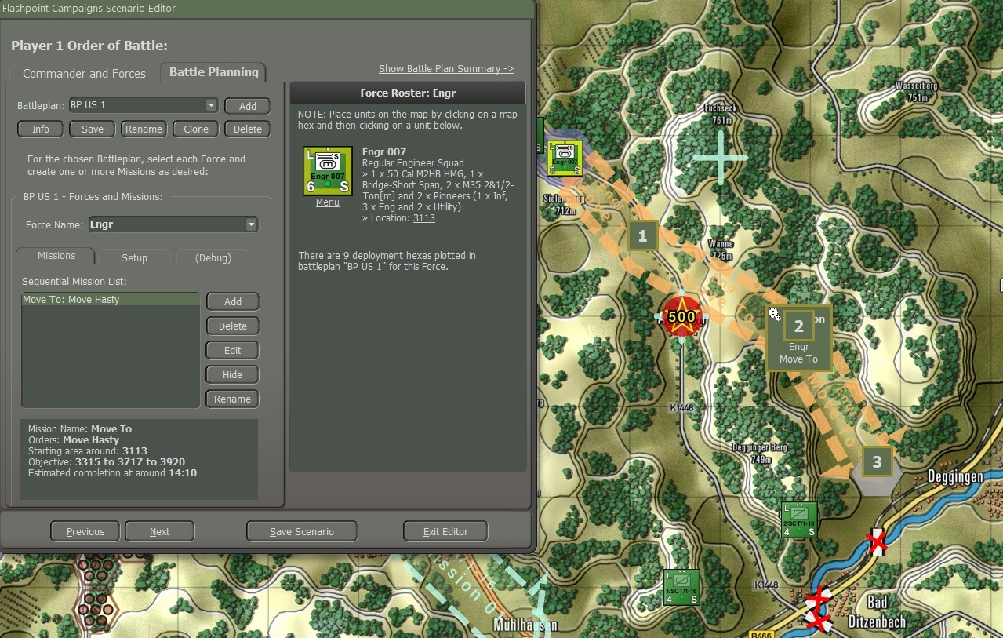

Fig. 34

You then “Add” a new mission for the Force and select “Bridge” from the orders as shown in Fig. 35.

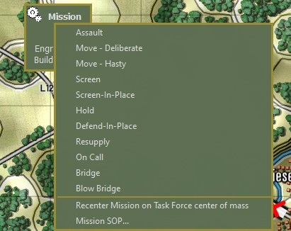

Fig. 35

Next place the three waypoints along the river where the engineering unit will lay a bridge as shown in Fig. 36.

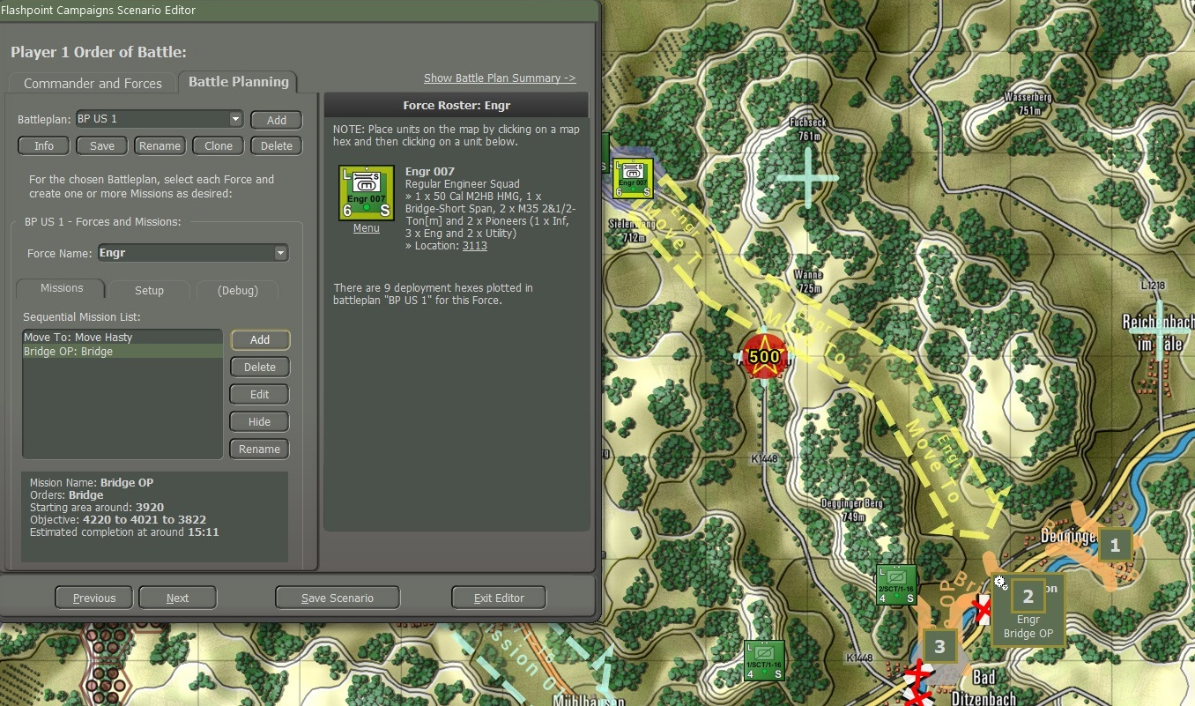

Fig. 36

The AI will select one of the three waypoints as the bridging location.

To set my engineer unit SOP, I select from the “Set SOP” and select “Engineer under Fire” as shown in Fig. 37.

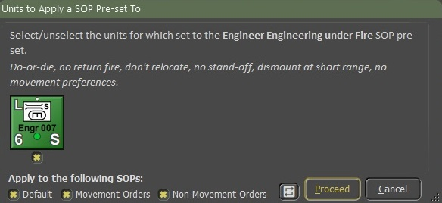

Fig. 37

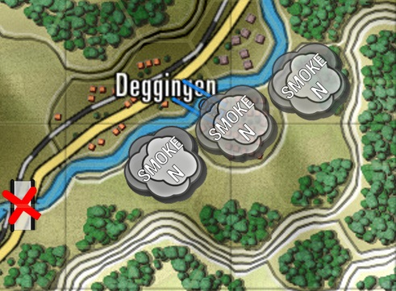

Fig. 38

With the units hidden, you can see the smoke screen as well as the bridge starting to be laid by the engineers at the first waypoint. It moved to the third waypoint and then to the second one before deciding to select the first waypoint as shown in Fig. 38.

The Artillery began to fire smoke in front of the engineer unit with the engineer unit being the spotter as shown in Fig. 39.

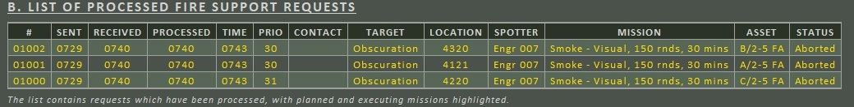

Fig. 39

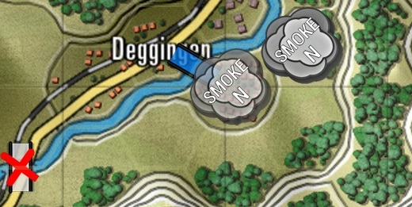

Fig. 40

Fig. 40 shows the bridge laid.

The computer player will decide to bridge solely in two situations:

1. if there is no alternative way to cross a water obstacle (and it has bridging available)
2. if explicitly told to create bridges by a Battleplan bridging mission. You need to mark the far side of the crossing. You can place multiple crossing locations. The computer player may attempt multiple simultaneous crossings (which is wise when the crossing is opposed) if the task force has multiple bridge layers, preferably in separate groups.

The computer player can identify alternative crossings, perhaps 5km away, and decide not to bridge.

(Since we don't have "sector boundaries" the computer player won't understand that alternative crossings are not viable. Since bridges are scarce, the computer player cannot use the Red Storm mechanism of constructing a bridge every time it runs into a water obstacle).

The second example will be C 1-16 INF (Armor) with an engineer bridge short span attached to the company.

I want to change the “Order of March’ in the company by selecting the “Reorder” and moving the Engineer unit and placing it behind the 1/C/1-16 and then followed by the 2/C/1-16 and 3/C/1-16.

After attaching an Engineer Bridging Unit to C/1-6 (Armor), hold the “Ctrl” key down and left-click on the Tank Company HQ, and all the units within the company are selected as shown in Fig. 41.

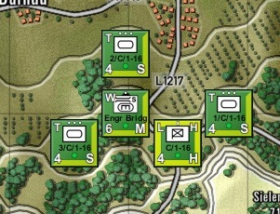

Fig. 41

The reason for doing that is I want to use large selections for the Set SOP and Adjust SOP mechanisms which have been designed to work with large selections of units. Even when you want to apply different changes to the HQ and line units of a group. It is quicker to select the whole group, apply changes to the whole group and confirm, then apply another SOP preset to the line units, exclude the HQ, and confirm. Finally, by selecting an SOP preset for the HQ, invert the selection including the HQ, and confirm. That way, you end up with the whole group still being selected, and ready to accept a group move order.

Another thing to remember is how to use the “Movement Orders” and the “Non-Movement Orders” as shown in Fig. 42.

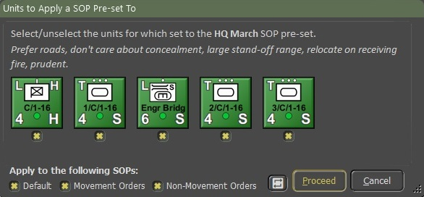

Fig. 42

If you want your units to behave differently “On the Move” compared to when they arrived and were in place. For example, to have your tank units quickly move into their screen and fight positions, you want them to use the roads. But once screening, you want them to fall back via locations and paths offering concealment.

To do so, select the tank units and adjust the SOP to prefer road movement for all SOPs (all checked as shown in Fig. 42).

Next issue the movements to the screening positions. Finally, select the tank units, adjust the SOP to not care about road movements, prefer concealed movement, and apply the changes only to the Defaults SOP and Non-Movement Orders, so you need to uncheck the Movement Orders.

For a quick inspection of specific actual Sop settings in your selection. For example, to check which units are set to “Maximum Range”, select the relevant units, then use the Adjust SOP and choose any Fire Discipline. The resulting confirmation dialog will show you the current fire discipline setting for each selected unit as shown in Fig. 43.

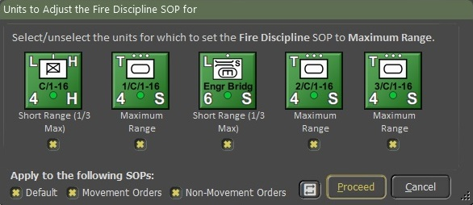

Fig. 43

Now, we will click on the “**Add**” button to add a mission.

Add “Mission Advance:” Move Hasty, then “Bridge Ops: Bridge, and then Advance 01: Move Deliberate as shown in Fig. 44, 45, and 46.

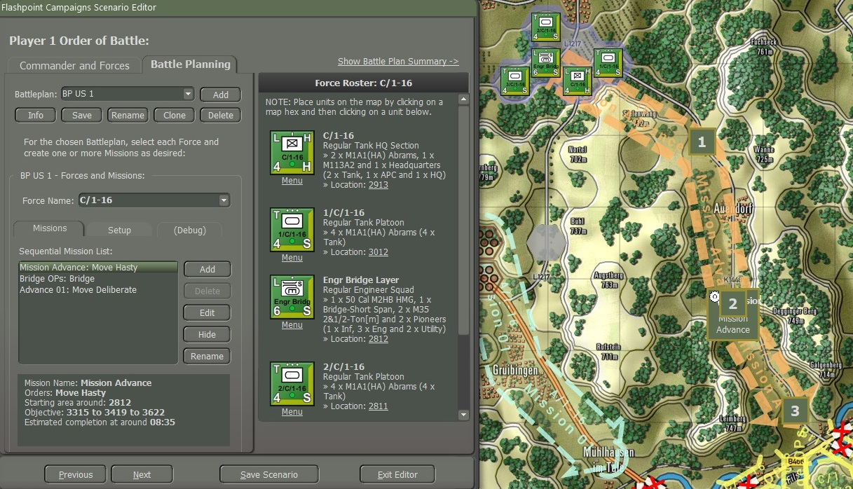

Fig. 44

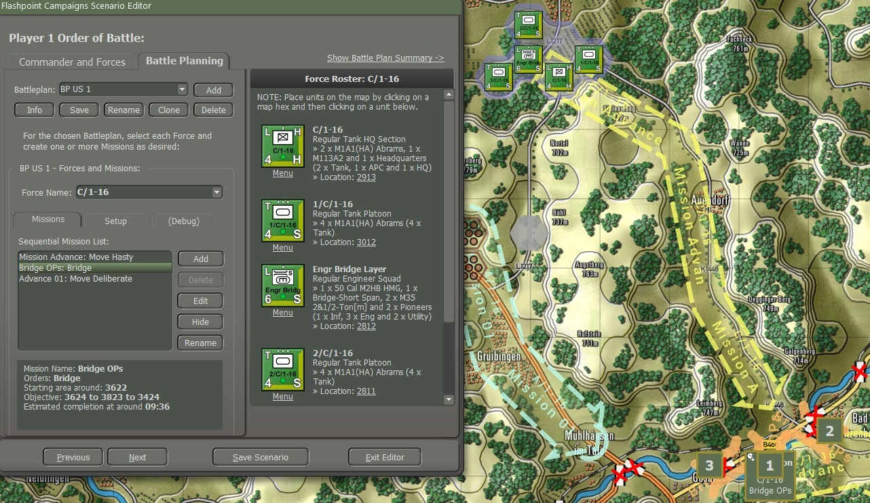

Fig. 45

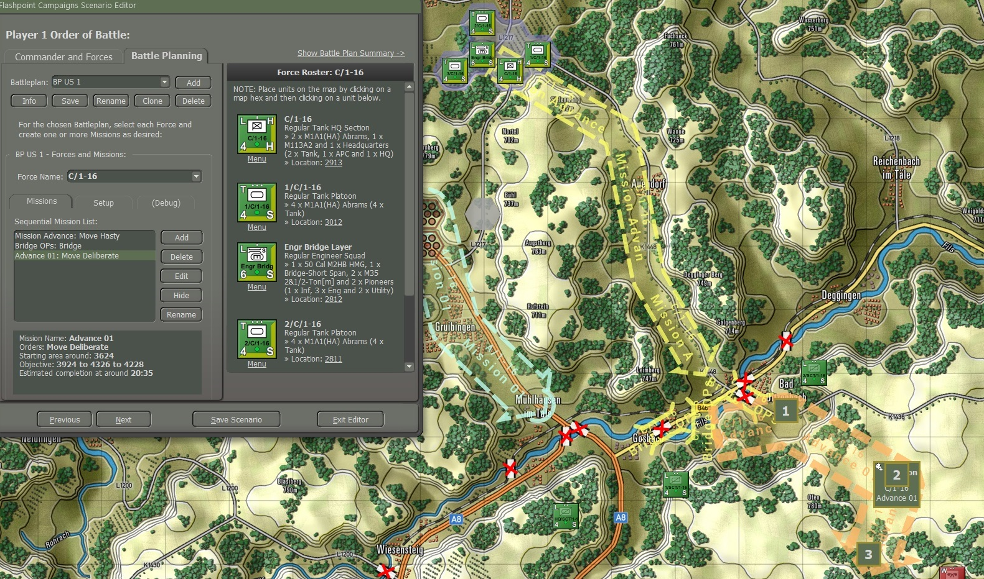

Fig. 46

Once I have set up my missions, I need to save it by selecting the “**Save**” button.

Looking at Fig. 47 you can see that artillery is firing smoke rounds to cancel the engineers laying a bridge, while 3/C/1-6 is providing support to the engineers, while the rest of the company is in a hold position until the bridge is laid.

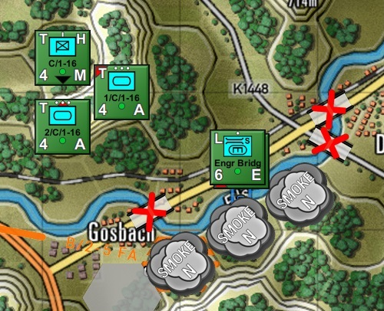

Fig. 47

Fig. 48 shows the 3/C/1-16 unit has crossed over the bridge, and the rest of the company is moving to cross over the river to continue with the mission. Unfortunately, the engineer bridge layer will not recover the bridge to continue with the C/1-16 mission. Just add more bridge layers to the task force. That feels safer and is more robust than removing the bridge from the obstacle you just crossed, disconnecting you from supply and reinforcements (and perhaps stragglers from your formation still on the wrong side of the obstacle).

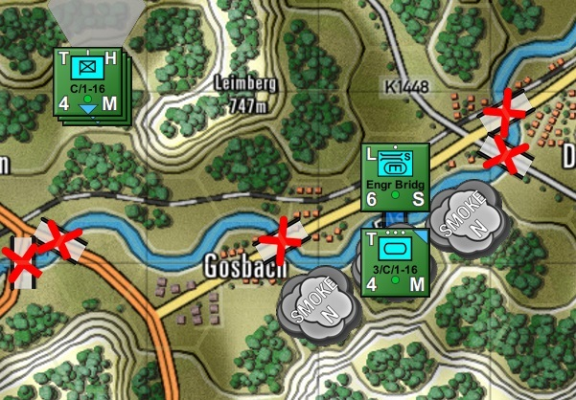

Fig. 48

One thing to remember is because we don't have "sector boundaries" the computer player won't understand that alternative crossings are not viable. That is why I had to destroy bridges so that the unit would have to hold in a position until the bridge was laid as shown in Fig. 47. If the bridges weren’t blown the units would cross over the other bridges and ignore the Engineer unit.

## Helicopters

Feature to be added in a future expansion.

# Battle Plans SOPs

Standard 0perating Procedures are designed to ensure consistency, efficiency, and effectiveness in executing operations while minimizing risks and maximizing the chances of success on the battlefield.

For more details on “Standard Operating Procedures” see “Section 23 **FM01 Game Operations**”.

## SOP Manager

All SOP changes by the SOP Manager can now be confirmed or canceled. When pressing Apply in the SOP Manager, or from any other menu, a dialog will be displayed listing the units involved (in OOB order) with the ability to conform, cancel, and/or change the selection of units as shown in Figure 49.

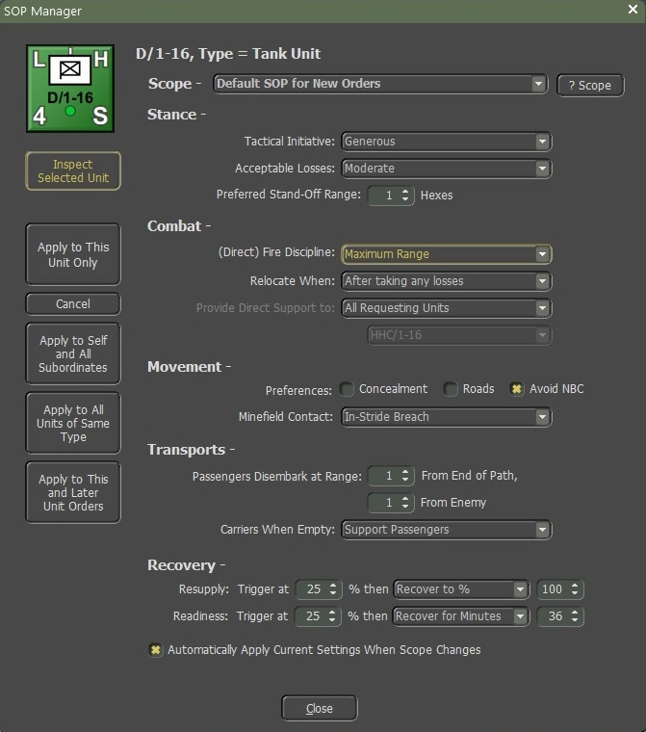

Figure 49

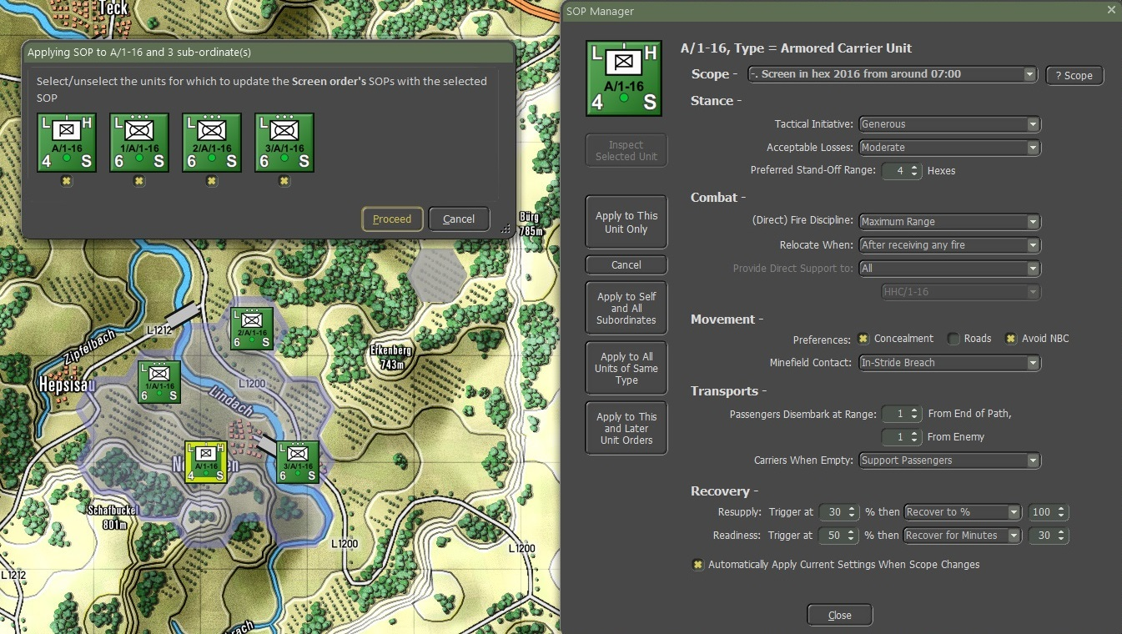

Fig. 50

Clicking a counter on the dashboard toggles the selection and highlights that unit’s position on the map.

The ability to unselect units in the confirmation dialog also allows you to check a group of units selected, and selectively apply changes, instead of having to deselect/reselect units on the map.

There are two ways to change or apply SOPs: Set SOPs and Adjusted SOPs.

## Set SOPs

“Set SOP” allows you to apply a SOP Preset to the selected units. A collection of SOP Presets has been made available from the menu, organized by unit type as shown in Figure 51.

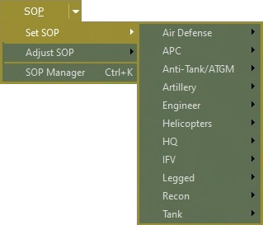

Fig. 51

To apply an “IFV Ambush” pre-set to a selection of units, go to the top SOP menu or the Unit menu, “Set SOP”, “IFV”, and IFV Ambush” as shown in Figure 52.

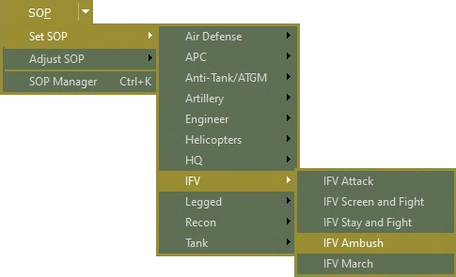

Fig. 52

For this example, we will select A Company 1-16 INF. To do that highlight the company headquarters, hold down the “**Ctrl**” key, and then select the company headquarters, it will show the entire company as shown in Figure 16.

The game will then present a confirmation dialog for the “IFV Ambush”, with a brief description of the key SOP elements being set in italics, and the same selection mechanism as the other SOP confirmation dialogs as shown in Figure 53.

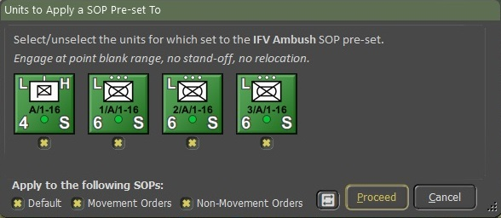

Fig. 53

Select the “**Proceed**” button and the SOP for these units will be updated in the SOP Manager.

## Adjust SOPs

“Adjust SOP” allows you to apply changes of one SOP element to the selected unit(s) as shown in Figure 54.

For example, go to the top SOP menu or the Unit menu, “Adjust SOP”, “Relocate When”, and “After Receiving Direct Fire” as shown in Figure 54.

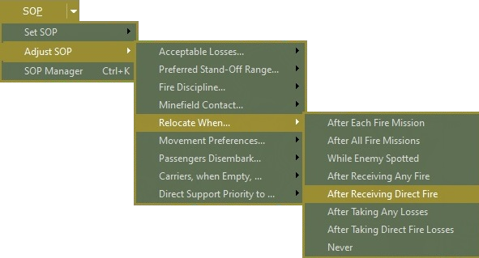

Fig. 54

The game will present a confirmation dialog for the Relocate When change, listing all selected units along with their currently active SOP for “Relocate When”.

The dialog repeats the SOP change you have chosen in bold as shown in Figure 55. Select the “**Proceed**” button and the SOP Manager will get an update.

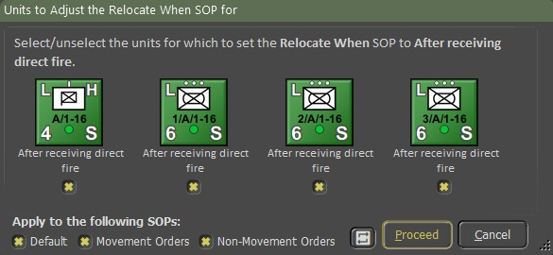

Fig. 55

Figure 56 shows an example of an SOP cheat sheet with the data already filled out for a quick reference of an SOP.

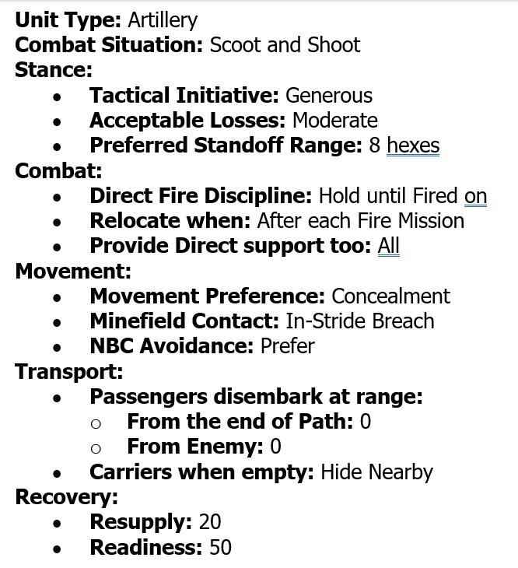

Fig. 56

# Battle Plans for Off-map Artillery and Air Force

## Off-map Artillery

We’ve created an Artillery Task Force and labeled it “2-5 FA”. Next, we will create a mission by selecting the “**Add**” button. A mission icon will appear at the border of the map closet to where the task force is positioned off-map as shown in Figure 18.

The first mission will be an “On-Call”, looking at my cheat sheet for my SOPs for Unit Type: “Artillery” and the Combat Situation: “Scoot and Shoot”, to see a copy of my cheat sheet see Figure 56. To set up the SOP for the 2-5 FA select the “**Edit**” button as illustrated in Figure 57.

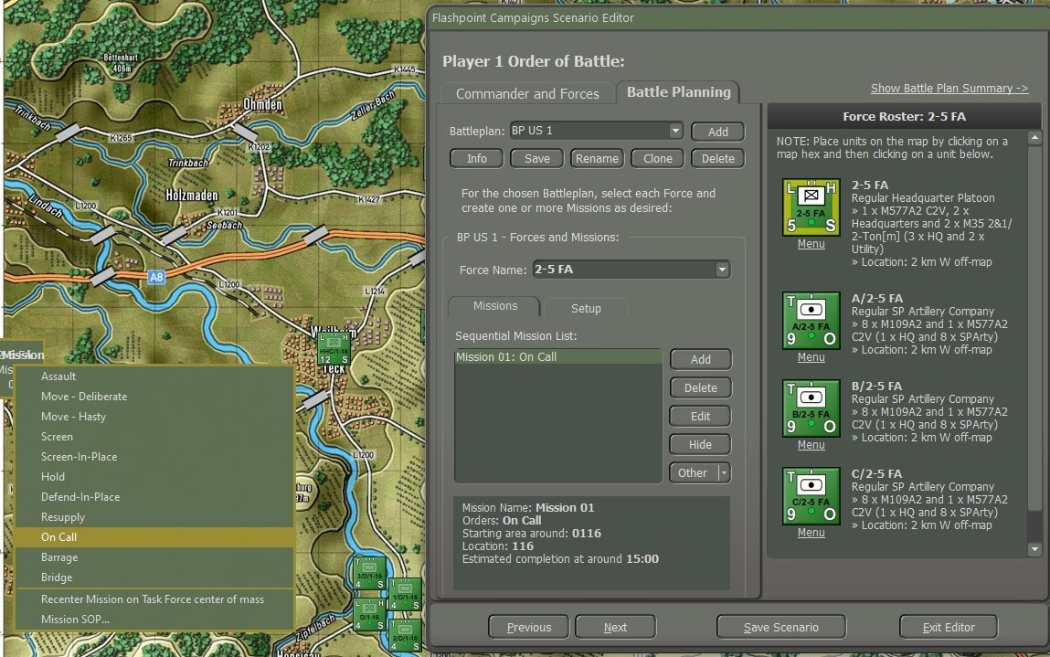

Fig. 57

A popup screen as shown in Figure 58 shows the 2-5 FA Mission Parameters.

To make the changes I will go to the “**Edit Mission SOP**” button and use “Set SOP” and then to the “Adjust SOP” to make the SOP as it is on my cheat sheet. An example of my Cheat Sheet is shown in Figure 56.

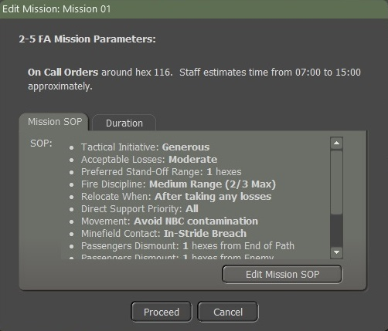

Fig. 58

Once you have made the changes, select the “**Apply to Self and All Insubordinates**” button to make the changes to all the units in the 2-5 FA as shown in Figure 49. When you select the “**Apply to Self and** **All Insubordinates**” button you will get a popup screen as shown in Figure 59.

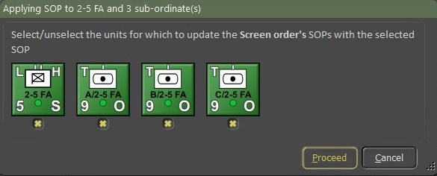

Fig. 59

For the Duration of this mission “On Call”, the duration of 480 minutes (8 hours) is changed to 60 minutes (1 hour) as illustrated by Figure 60. Once done select the “Proceed” button.

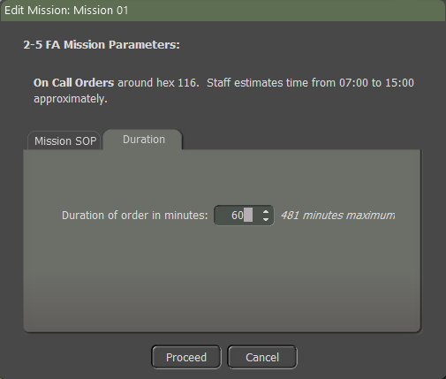

Fig. 60

Next, add a new mission that will start after the one hour is up for the first mission “On call". For this mission, we will do a Barrage mission.

### Impacts of Artillery Barrage

Using BPs for Indirect fires is good for representing pre-planned strikes on known or guessed enemy locations or for screening assaults or crossings with smoke and HE.

Use the Artillery Barrage for the attacking side - trying to wear down where the defenders might be - if you think that one side would have enough Int to do these attacks. When you use them, try to give three targets to a Regt/Bn - usually close together.  After you set up a couple of rounds of barrages and then give the unit a resupply mission before going to an On-Call mission.

You should make sure that all those missions will be neutralization missions.

## Off-map Air Force

After creating an Air Task Force labeled for this example, “52 TFW”, let's assign an Airstrike to 52 TFW, and create a new mission by selecting the “Add” button. A screen will pop up as shown in Figure 61, type in the box “Strike 01”, and select the “**Proceed**” button.

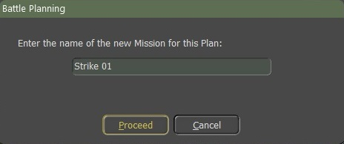

Fig. 61

A mission icon will appear at the border of the map, closest to where the task force is positioned off-map.

That is, on the left map border if the task force is placed west of the map, on the top border if the task force is placed north of the map, etc.

Change the mission to an airstrike by right-clicking on the mission box and selecting “Air Strike” as shown in Figure 62.

A popup screen as shown in Figure 63 where you must place one to three Battle Planning waypoints to where you want the air strikes as shown in Figure 64. When done select the “**Commit**” button.

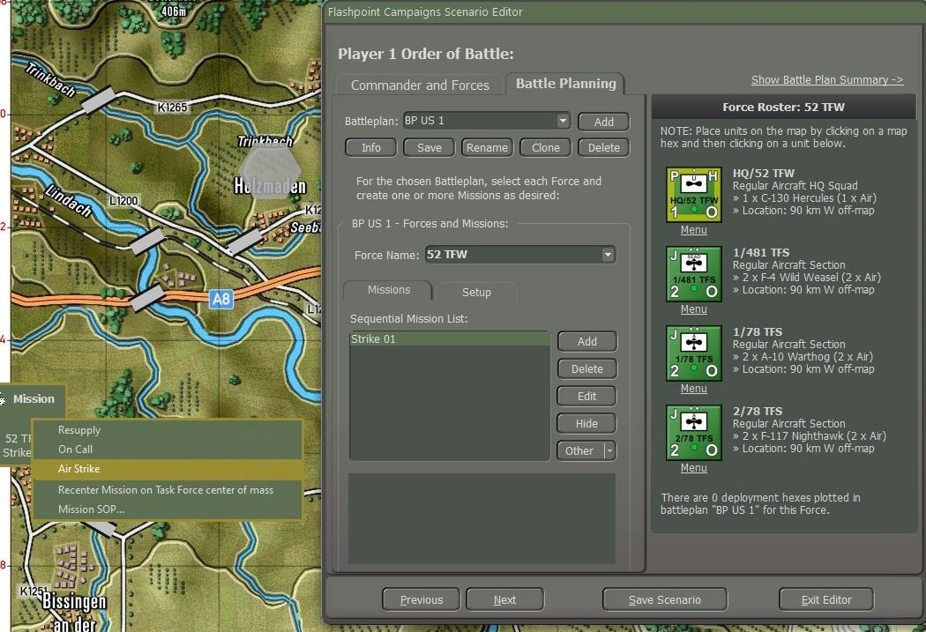

Fig. 62

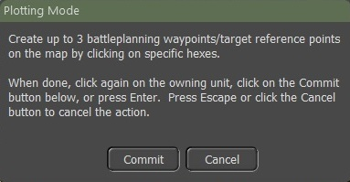

Fig. 63

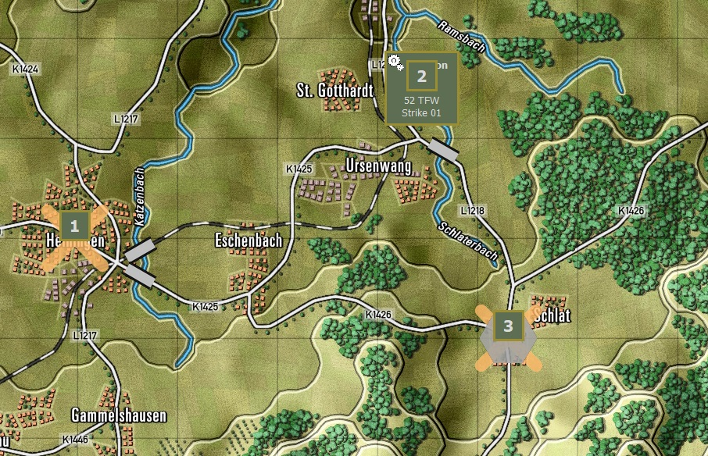

Fig. 64

Add a second mission and make this one a Resupply (aka Re-Organize). Select the “**Add**” button and add the name “Resupply off-map” in the popup screen as shown when you add “Strike 01” as from Figure 61 and select the “**Proceed**” button.

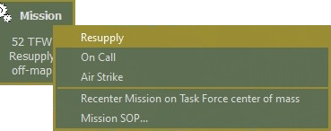

Fig. 65

Right-click in the Misson block and select “Resupply” as shown in Figure 65, and a number one (1) will show in the mission block as shown in Figure 66.

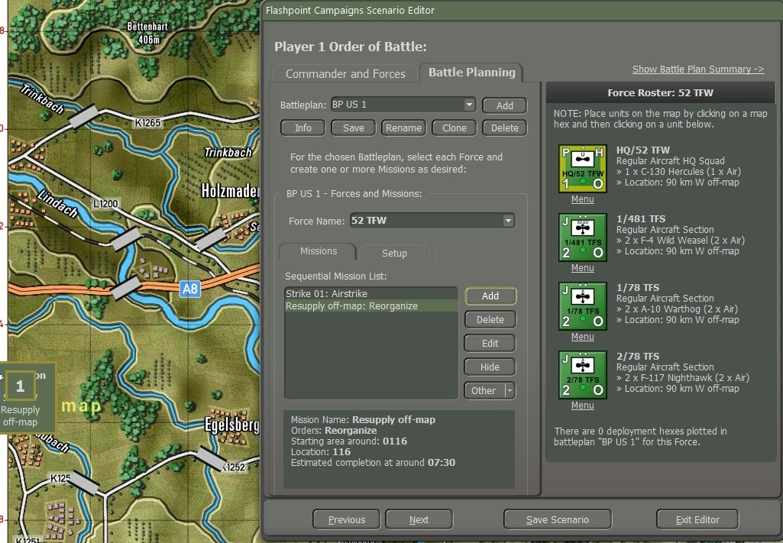

Fig. 66

Proceed with adding another air strike and resupply to replenish loadouts.

Figure 67 shows the (**1**) “Sequential Mission List” and below is the (**2**) “Mission Box” first mission showing the Mission name, Orders, Starting area around, targets, and estimated completion time.

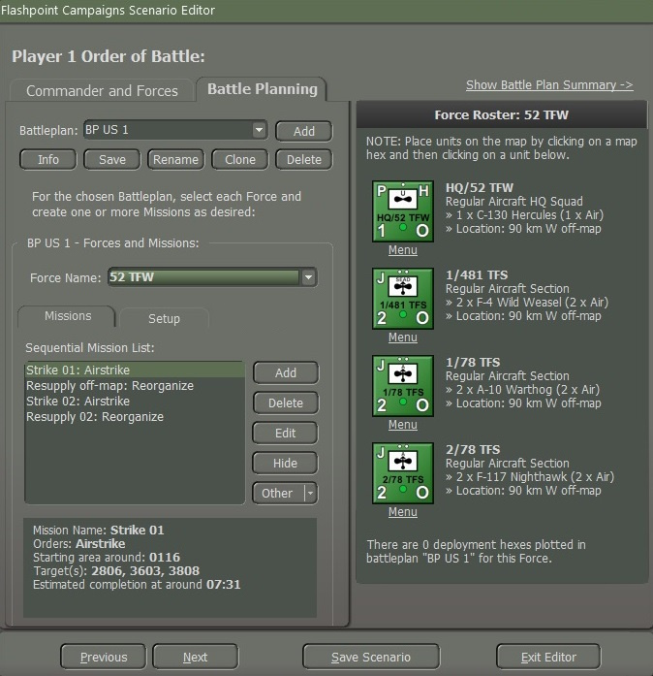

Fig. 67

### Impact of Air Strike Waypoints

Airstrike waypoints indicate the vicinity in which the CAS unit will look for and engage targets. Normal CAS units will search for and engage a single “target rich” hex within 1500m (3 hexes), whereas SEAD units will search for and engage a single “Radar target rich” within 5000m (5 hexes).

If the task force contains a single air group, it will be tasked with one (1) single (most promising) of these waypoints (with known nearby enemy units making a waypoint more promising and preferring to the first waypoint if no targets are known.

If the task force contains multiple air groups, each air group will be tasked with one of those (most promising) waypoints, in such a way that the groups are distributed over the waypoints.

### Execution of Battle Plan Air Strikes

When an (off-map) group starts an airstrike, the group units are split into SEAD-capable units, airstrike-capable units, and other units. The “other” units won’t participate in the airstrikes.

SEAD units are tasked first, with an airstrike order in the vicinity of the given waypoint, towards known enemy locations. SEAD units are given a large vicinity to engage targets and prefer to engage air search RADAR-equipped targets.

Next, the airstrike units are tasked with airstrike orders.

All air units from the same group are tasked with one (1) minute intervals, to mimic “de-conflicting”.

**NOTE:** the typical order delay for an air unit to perform an airstrike is twenty (20) minutes, so expect aircraft to arrive approximately twenty (20) minutes after the start of the airstrike mission.

### Execution of Non-Battle Plan with Off-map Air Strikes

Without a battle plan (mission) to execute and all air units supplied and on-call, the AI will attempt to identify rich targets and issue strike missions, followed by a resupply. Again, the typical delay for the airstrike to come is twenty (20) minutes, during which time the rich target might have left.

When using groups, do not put SEAD units into a single group but add them to groups with normal strike aircraft. This way, the SEAD units will precede the normal strike aircraft.

Use an unarmed utility aircraft as a virtual HQ unit, being an unarmed utility aircraft prevents it from joining the airstrikes and may get shot down.

# Battle Planning Dos and Don’t

* A Battle Plan Mission adopts the Standard Operating Procedure (SOP) of the Force's headquarters it serves. However, this SOP may not always align perfectly with the mission's requirements. It is essential to review the SOP for the mission and make necessary adjustments through the Edit Button.
* If the mission’s name doesn't suit your preferences, simply opt to modify it by choosing "Rename" from the dropdown menu accessible through the "Other" button situated to the right of the Mission list, below the "Hide" button.
* If the Mission icon obstructs the hex where you intend to place a Waypoint (e.g., with a Screen or Hold mission), there are two methods to position the Waypoint:

1. The initial approach involves left-clicking on the mission’s name within the "Sequential Mission List." This action hides the mission icon on the map, enabling you to place the waypoint freely.
2. Alternatively, you can initially position the waypoint elsewhere and subsequently drag it to the desired hex location.

* Ensure that you remember to place waypoints on the map for missions that necessitate them, such as screen and hold orders (this step is straightforward). Neglecting to do so will result in the mission being left "unassigned," ultimately leading to its failure.
* You can allocate artillery barrage missions. When designating a barrage mission, you can establish three waypoints. If the force possesses multiple artillery batteries, each waypoint will be assigned a battery, starting with the first battery in the Order of Battle (OOB) tree. This allows for the setup of various types of barrages. For instance, in a scenario, you can allocate an Artillery Force with three batteries to three distinct barrage missions: smoke, persistent chemical, and non-persistent chemical. However, if you designate more waypoints than there are batteries available (for example, setting three waypoints with only one or two batteries in the force), the surplus waypoints will not be assigned barrages.
* To conceal the Battle Plan graphics, simply click the "Hide" button located to the right of the Mission list, beneath the "Edit" button. To restore the graphics, click on the same button once more.
* Battle Plan Missions are subject to time constraints. Upon expiration of the allotted time for a Battle Plan Mission, the unit will proceed to the subsequent mission. It is advisable for the player to thoroughly test their Battle Plans and make necessary adjustments to ensure their proper execution.
* For each Battle Plan, units have the flexibility to be relocated to different setup hexes.
* It's not mandatory for forces to have Battle Plan Missions. When a unit lacks a mission, the AI takes control and moves the units according to its discretion. A Battle Plan can simply involve units or forces relocating to different locations without specific assigned missions. Additionally, a Battle Plan may include some units or forces with missions and others without.
* Battle Plan Waypoints can be moved and adjusted once they are set.
* Ensure that emitters such as Air Search Radar on units are activated to ensure their functionality within the Battle Planner.
* The entry hex for reinforcements can be adjusted for each Battle Plan. However, currently, players cannot alter the timing of their entry.

# Flashpoint Campaigns Credits

## On Target Simulations Team

* Lead Programmer and Head Honcho: **Robert "Ironman" Crandall**
* Data, Programming, Graphics, and Sound: **Jim "Cap’n Darwin” Snyder**
* Programming, Data, Models, and Research: **Jeff “Iron Mike” Sugden**
* Map Master, Programmer, AI, and Graphics: **William van der Sterren**
* Quality Czar and Testing Lead: **Charles “The Whip” Belva**
* Programming: **Kevin “SgtZDog” Zemon, Will Jackson, Alex Kriesel**
* Testing: **Tomasz Niedzinski**
* Scenario and Campaign Design Lead: **Joao Lima**

## Cold War Contributors/Testers

* Alexander “Stimpak” Schwarz, Bryan “Tazak” Jones, David “22sec” Whitt, Mike “MikeJ19” Johnstone, Jurrie van der Zwaan, John “JohnO” Osborne, Jorgen “Jotte” Torgersson, Jo van der Pluym, Scott “WABAC” Gibbs and Steve “Mad Russian” Overton

## Cold War Beta Testers

* Alexander “Lomo7j” Shestakov, Bas “Baskaatje” Kreuger, Calvin Breaker, ||CptMiller||, Craig “CTCharger” Truesdell, Dario Miroli, Dave Duckett, David “ultradave” Anderson, Don “Dovs” Lazov, Doug Miller, Durkik "gucciflocka97" Koth, Eemeli “Kurrestan” Sorri, Eric Estes, Exsonic01, Gary Bezant, Gary Heintz, Harry “harry_vdk” van der Kooij, Henry Simpson, Howard Rigg, Hoyt Burrass, Ian Strauss, Jack Herling, James Cleeter, Jing “cristianwj” Wang, Jonas Solberg, Jonathan (Yogdog) Brown, Justin Wonderlick, Kamyar Ashfar, Marc Bellizzi, MadGuard, Mark “nelmsm” Nelms, Maxime Lemieux, Nefron, Panta “Panta_slith” Astiazaran, Patrick Walker, PullG, Reto “rgeiger” Geiger, Richard “The Plodder” Lloyd, Ringtailhawk, Robert “rsallen64” Allen, Searry, Shannon “ObfuscatedJava” Morgan, Stas “StasSche” Schebetov, Steve (CV90) Lohr, TarkError, Terry Barnes, Todd “sfbaytf” Fong, Todd Bergquist, Tommi “Tomcatter” Saarainen, Tyler "daddywarlord" Knapp, Ai “Xavier Jot” Zhang

## Matrix Production Manager

* **Erik Rutins** – The man behind the curtain keeping us on task!

# OTS on the Web

Matrix Games Forum: <https://www.matrixgames.com/forums/viewforum.php?f=10149>

Check Us Out on Steam: <https://store.steampowered.com/app/2366530/Flashpoint_Campaigns_Southern_Storm/>

Check Us Out on Discord: <https://discord.com/channels/911711314051739659/911711314257248331>

OTS Facebook Page: <https://www.facebook.com/ontargetsimulations>

**© 2025 On Target Simulations, LTD. All Rights Reserved. The images used and OTS Logo are property of On Target Simulations, LTD. All other logos and trademarks are the property of their respective owners.**